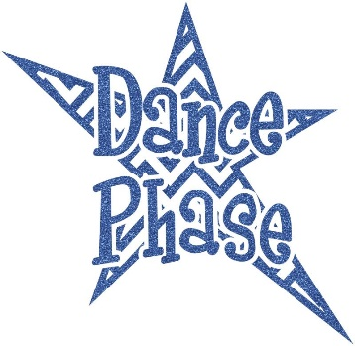 **Dance Phase Studio**

**2024-2025 Fall Schedule**

|  |  |  |  |  |
| --- | --- | --- | --- | --- |
| **BALLET (8yrs & Up)** | **TAP (8yrs & up)** | **JAZZ (8yrs & up)** | **HIP HOP (8yrs & Up)** | **ACRO** |
| **Level 1: Tues. 4:30** | Level 1: Tues. 5:30 | Level 1: Tues. 6:30 | Level 1: Thurs. 5:30 | 7 & Under: Thurs. 5:30 |
| **Level 2: Thurs. 6:00\*** | Level 2: Tues. 5:30 | Level 2: Tues. 6:30 | Level 2/3: Tues. 7:30 | 8-11yrs: Thurs. 6:30 |
| **Level 3: Tues. 4:15\*** | Level 3: Tues. 5:30 | Level 3: Thurs. 4:30* | BOYS: Mon. 6:15 | 12 & Up: TBD |
| **Level 4: Mon. 6:00\*** | Level 4/5: Mon. 5:00 | Level 4: Wed. 4:15* |  |  |
| **Level 5: Mon. 6:00\*** |  | Level 5: Wed. 4:15* |  |  |
|  |  |  |  |  |
| **POINTE/PRE POINTE** | **LYRICAL/CONTEMP (10-14)** | **ALL STAR POM** | **ADULT TAP** |  |
| **Monday @ 7:30** | **TUES. 7:30** | **Thurs. 4:30** | Level 1 Mon. 7:00 |  |
|  |  |  | Level 2 Mon. 6:30 |  |

|  |  |  |  |  |
| --- | --- | --- | --- | --- |
| **TWIRLING TOES (18MTHS-2 YRS)** | **¾ BALLET/TAP COMBO** | **5/7 BALLET/TAP** | **5/7 JAZZ/HH** | **ADV. COMBO (8-10YRS)**  **TAP, BALLET & JAZZ** |
|  |  | Mon. 4:45 | Mon. 5:30 | Mon. 5:30 |
| Wed. 4:45 | Mon. 4:45 pm | Wed. 6:15 | Wed. 7:00 |  |
|  | Wed. 5:30 pm | Thur. 7:00 | Thurs. 6:15 |  |
| **MUSICAL THEATER** |  |  |  | **TECHNIQUE 8 & UP** |
| Level 1: Tues. 4:30 |  |  | COMPANY - TBD | Sat. 9:00-10:30am* |
| Level 2: Thurs. 7:30 |  |  |  |  |
|  |  |  |  |  |